How to manage your group through MyApps:

Open MyApps through a web browser:
- https://myapplications.microsoft.com/
Click the drop-down arrow next to My Apps In the upper left corner of the MyApps homepage
- Then click My Groups
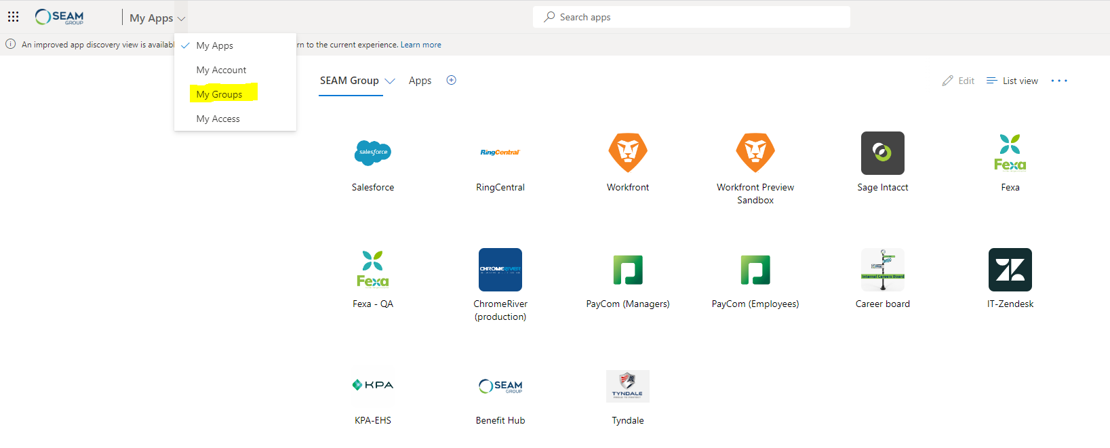

Once you select My Groups from the dropdown, a new page will open.
This will display a column titled: Groups I own.
- Click on the group you would like to modify.
- A properties page will open on the group.
- On the right-hand side, the Members list will be displayed.
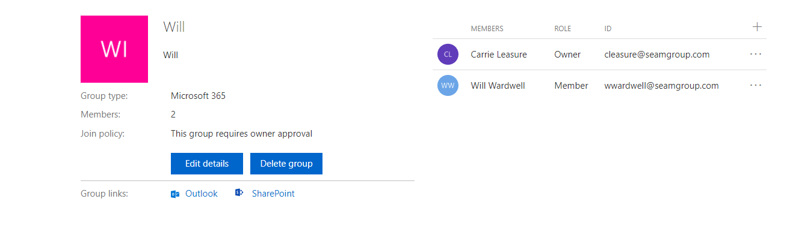

If you need to add a member:
- Select the + sign in the upper right hand corner and search the user by name or email
- Click on the name of the person then select Add
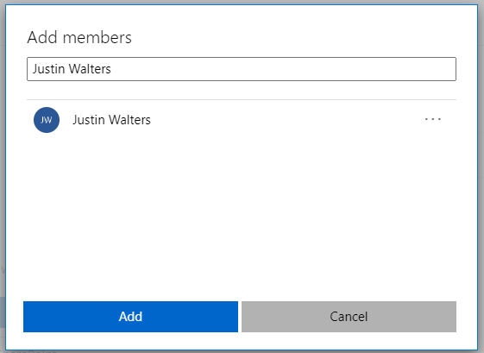

To remove a user:
- Click the three dots at the end of the users name
- Select Remove member

